Lagged cross-correlation: USDJPY and EURGBP
Method 12 / daily log returns / K_max=10 / Alpari D1 full available history

Study setup
Logical pair: USDJPY , EURGBP
Broker symbols: USDJPY_i , EURGBP_i
Snapshot: 2026-11-03_majors_alpari_D1
Timeframe: D1
Matched return window: 1999-01-06 to 2026-11-02 (UTC bar dates)
Matched return count n: 7181
Dropped unfinished last bar dated 2026-11-03 UTC after a tick-volume check against the prior complete day.
Lag definition: rho_X->Y(k) = Corr(x_t, y_{t+k}) on matched D1 bars
K_max = 10; headline lag k = 1 (both directions)
Complete matched rows (Excel): USDJPY-EURGBP_Lagged_D1.xlsx
Complete matched rows (HTML table): USDJPY-EURGBP_Lagged_D1_data.html

Method carried forward
Lagged cross-correlation measures Pearson correlation between matched daily log returns of close, ln(close_t / close_t-1), after shifting one series forward by k bars on the matched panel. Quotes are not inverted. rho_{X->Y}(k) = Corr(x_t, y_{t+k}) with n_k = n - k. K_max = 10 is fixed before estimation. The headline is the pre-specified lag k = 1 in both directions. k = 0 is the same-bar side check. The lag inside 1..10 with the largest absolute rho is stored as a descriptive column only; it is not a selected result. This is a linear screen, not proof of forecast edge, economic cause, or a trading signal.

Results (headline k=1)
rho_USDJPY->EURGBP(1): -0.012227 (n=7180)
95% Fisher interval USDJPY->EURGBP: [-0.035348, 0.010907]
rho_EURGBP->USDJPY(1): -0.006573 (n=7180)
95% Fisher interval EURGBP->USDJPY: [-0.029699, 0.016561]
Same-bar rho(k=0): -0.127992
Largest |rho| among k=1..10 (descriptive only, not selected): USDJPY->EURGBP k=10 rho=-0.021242; EURGBP->USDJPY k=4 rho=0.040141

CCF table
k | rho_USDJPY_to_EURGBP | n_USDJPY_to_EURGBP | rho_EURGBP_to_USDJPY | n_EURGBP_to_USDJPY
0 | -0.12799228 | 7181 | -0.12799228 | 7181
1 | -0.01222691 | 7180 | -0.00657273 | 7180
2 | -0.01382511 | 7179 | -0.01246851 | 7179
3 | 0.00792366 | 7178 | 0.01505093 | 7178
4 | 0.00040508 | 7177 | 0.04014129 | 7177
5 | 0.00376868 | 7176 | -0.02927793 | 7176
6 | -0.00547654 | 7175 | -0.00483872 | 7175
7 | -0.00659328 | 7174 | -0.0160239 | 7174
8 | -0.01522203 | 7173 | -0.012481 | 7173
9 | -0.00300932 | 7172 | -0.00895092 | 7172
10 | -0.02124233 | 7171 | -0.01130884 | 7171

Conclusion
At the pre-specified lag k=1 for USDJPY and EURGBP, rho_{USDJPY->EURGBP}(1) = -0.0122 (n=7180) and rho_{EURGBP->USDJPY}(1) = -0.0066 (n=7180). Same-bar rho(k=0) = -0.1280. Largest |rho| among k=1..10 is descriptive only: USDJPY->EURGBP at k=10 (-0.0212); EURGBP->USDJPY at k=4 (0.0401). This is a linear screen, not forecast proof or a trading signal.

Charts
Daily closes

Daily log returns

CCF both directions k=0..10
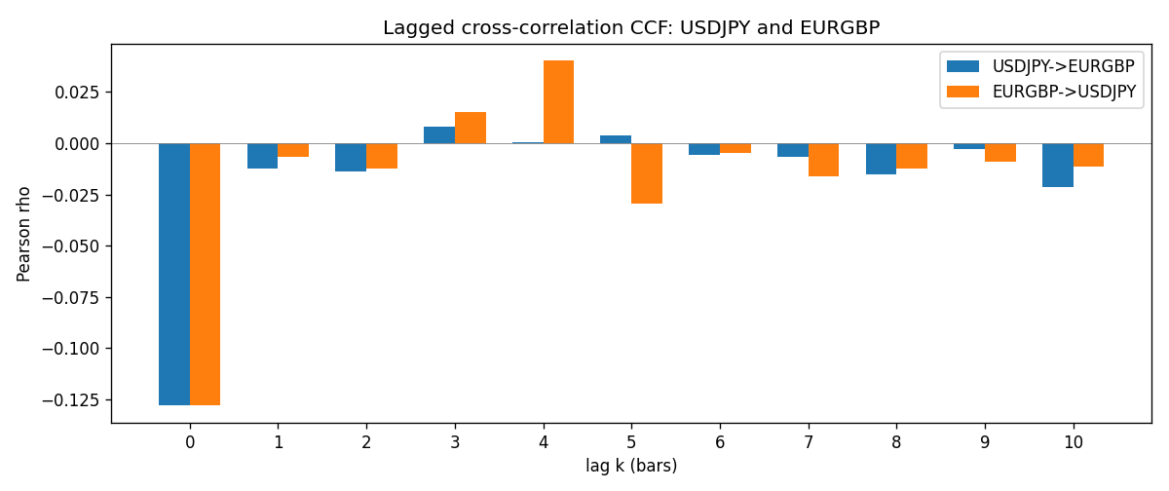

Data report
Every matched row is stored in the sibling Excel workbook named USDJPY-EURGBP_Lagged_D1.xlsx (sheet matched_rows). The CCF sheet holds rho(k) for k=0..10. Embedding all rows as a Word table is impractical; the Word file holds column summaries and the first and last 15 rows.
Columns: time, USDJPY_open, EURGBP_open, USDJPY_high, EURGBP_high, USDJPY_low, EURGBP_low, USDJPY_close, EURGBP_close, USDJPY_tick_volume, EURGBP_tick_volume, USDJPY_spread, EURGBP_spread, USDJPY_real_volume, EURGBP_real_volume, USDJPY_log_return, EURGBP_log_return
Column summaries (matched calculation rows)
column | count | mean | std | min | 25% | 50% | 75% | max
USDJPY_open | 7181 | 113.80773 | 19.228846 | 75.693 | 104.38 | 110.98 | 120.71 | 163.824
EURGBP_open | 7181 | 0.78701429 | 0.09663819 | 0.5734 | 0.6877 | 0.83392 | 0.86523 | 0.9769
USDJPY_high | 7181 | 114.30513 | 19.290536 | 76.001 | 104.865 | 111.439 | 121.27 | 163.978
EURGBP_high | 7181 | 0.79009197 | 0.09701345 | 0.5789 | 0.6897 | 0.83701 | 0.8681 | 0.9799
USDJPY_low | 7181 | 113.28458 | 19.156841 | 75.402 | 103.87 | 110.53 | 120.172 | 163.628
EURGBP_low | 7181 | 0.78431381 | 0.09645598 | 0.5682 | 0.6857 | 0.83166 | 0.86287 | 0.9661
USDJPY_close | 7181 | 113.82069 | 19.244339 | 75.811 | 104.38 | 111.015 | 120.695 | 163.851
EURGBP_close | 7181 | 0.78705735 | 0.09663932 | 0.5735 | 0.6878 | 0.83401 | 0.86539 | 0.977
USDJPY_tick_volume | 7181 | 106398.86 | 179473.16 | 149 | 9958 | 53207 | 92916 | 1803508
EURGBP_tick_volume | 7181 | 87156.048 | 145513.65 | 154 | 6593 | 44384 | 81451 | 1424684
USDJPY_spread | 7181 | 20.250104 | 17.60648 | 0 | 6 | 11 | 30 | 50
EURGBP_spread | 7181 | 21.316669 | 19.115948 | 0 | 4 | 13 | 40 | 50
USDJPY_real_volume | 7181 | 3.4800425e+10 | 1.6097887e+11 | 0 | 0 | 0 | 0 | 3.8834203e+12
EURGBP_real_volume | 7181 | 2.788005e+10 | 1.3523257e+11 | 0 | 0 | 0 | 0 | 3.5726265e+12
USDJPY_log_return | 7181 | 4.847e-05 | 0.00620794 | -0.03908203 | -0.00320533 | 0.00011473 | 0.00340924 | 0.05184024
EURGBP_log_return | 7181 | 2.133e-05 | 0.00487349 | -0.03067367 | -0.00262366 | -0.00010035 | 0.00255918 | 0.06075387
First 15 matched rows (selected columns)
time | USDJPY_close | EURGBP_close | USDJPY_log_return | EURGBP_log_return
1999-01-06 | 112.77 | 0.7019 | 0.0075660159 | -0.013303338
1999-01-07 | 111.33 | 0.7097 | -0.012851583 | 0.011051402
1999-01-08 | 110.8 | 0.7062 | -0.0047719894 | -0.004943862
1999-01-11 | 109.02 | 0.7053 | -0.016195423 | -0.0012752393
1999-01-12 | 112.6 | 0.7077 | 0.032310364 | 0.0033970309
1999-01-13 | 113.52 | 0.708 | 0.0081373171 | 0.00042381861
1999-01-14 | 113.52 | 0.7066 | 0 | -0.0019793588
1999-01-15 | 114.15 | 0.7012 | 0.0055343401 | -0.0076715819
1999-01-18 | 114.16 | 0.7017 | 8.7600193e-05 | 0.00071280921
1999-01-19 | 113.52 | 0.7007 | -0.0056219403 | -0.0014261269
1999-01-20 | 112.91 | 0.7021 | -0.0053879917 | 0.0019960086
1999-01-21 | 113.87 | 0.7016 | 0.0084664056 | -0.00071240297
1999-01-22 | 114.56 | 0.7004 | 0.0060412564 | -0.0017118406
1999-01-25 | 113.72 | 0.6966 | -0.0073594164 | -0.0054402425
1999-01-26 | 113.86 | 0.6962 | 0.0012303367 | -0.00057438255
Last 15 matched rows (selected columns)
time | USDJPY_close | EURGBP_close | USDJPY_log_return | EURGBP_log_return
2026-10-13 | 158.305 | 0.84458 | -0.0018932826 | 0.00020130374
2026-10-14 | 158.317 | 0.84553 | 7.5800166e-05 | 0.0011241873
2026-10-15 | 158.024 | 0.84479 | -0.0018524319 | -0.00087557391
2026-10-16 | 157.964 | 0.84307 | -0.00037976126 | -0.0020380844
2026-10-19 | 158.517 | 0.84259 | 0.0034946841 | -0.00056950988
2026-10-20 | 158.16 | 0.83957 | -0.0022546642 | -0.0035906254
2026-10-21 | 158.108 | 0.83839 | -0.00032883504 | -0.00140647
2026-10-22 | 156.755 | 0.83682 | -0.0085942669 | -0.0018743924
2026-10-23 | 156.81 | 0.83751 | 0.00035080446 | 0.00082421033
2026-10-26 | 157.458 | 0.83762 | 0.0041238746 | 0.00013133309
2026-10-27 | 157.894 | 0.83595 | 0.0027651658 | -0.0019957343
2026-10-28 | 157.743 | 0.83651 | -0.00095679538 | 0.00066967224
2026-10-29 | 157.683 | 0.83553 | -0.00038043789 | -0.0011722209
2026-10-30 | 157.516 | 0.83351 | -0.0010596481 | -0.0024205543
2026-11-02 | 157.933 | 0.83426 | 0.0026438521 | 0.00089940465

